Daily Notebook & Social Networking Updater
BCA 6th Semester
CS-76(Project)

SK Monirul Islam
Enrollment No-085481170

Table of Contents
Introduction & Objective of the Project: 3
Project Category: 5
Analysis of the Project: 6
Daily notebook & Social Networking Updater GUI 6
View Manger: 7
Common Controls: 7
Engine Interaction: 7
Search Interface 8
Facebook Interface 8
Twitter Interface 8
Daily Note Interface 8
Blogger Interface 8
Linkedin Interface 8
Google buzz Interface 8
Orkut status Interface 9
RSS FEED Interface 9
Task / To Do Interface 9
Archive Interface 9
Daily notebook & Social Networking Updater Engine 10
Task / To Do Handler: 11
Daily Note Handler: 11
RSS Feed Watcher: 11
GUI Interactor: 11
Database Manager: 11
Search Engine: 11
Web Service Handler: 11
Data Update Manager: 11
Daily notebook & Social Networking Updater Database 11
Hardware & Software required for the application to run 12
Hardware Requirements 12
Software Requirements 12
Project Structure: 13
Project Estimation: 13
E-R Diagram: 14
Tools/Platforms used (Hardware/Software): 16
Hardware: 16
Software: 16
Any Client/Industry: 17
Future Scope and Further enhancement of the project: 18

Introduction & Objective of the Project:

Nowadays social networking is the main trend among us. We like to share whatever happening with us or around us and follow about others. We want to keep track of every possible thing in our life. Earlier day’s people used to maintain Notebook or Daily Diary to write down about their experiences. Now also we do same things but in different ways. With advent of new technologies we use twitter, facebook instead of maintaining a diary. As all of them are online services we can not access them without an internet connection and sometimes it takes lots of time to load or query our own posts from the server.
Daily notebook & Social Networking Updater will provide a way to organize our daily notes and status updates for social networking sites. It will allow users to add notes and update it to most popular social networking sites. User can add notes anytime and mark it for update, and then whenever user comes online the pending updates will be uploaded to the destination sites. Users will be able to download the RSS feed of the websites and the Daily notebook & Social Networking Updater will automatically download the feeds and make it available for offline view also. The overview of this software is displayed below in the diagram.

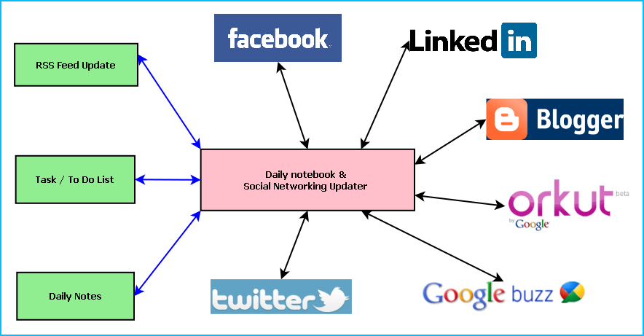
Figure: Overview of Daily notebook & Social Networking Updater

Main features of the Daily notebook & Social Networking Updater are:
- Maintaining daily notes
- Updating the status in Social Networking Sites and downloading the RSS feeds
- Facebook integration
- Twitter integration
- Blogger integration
- Linkedin integration
- Google buzz integration
- Orkut status integration
- Maintaining To Do/Task list
- Reminder/ alarm for scheduled task
- Printing of Notes, To Do & Tasks
- Archiving old data
- Searching Updates

Project Category:

This software will follow Object Oriented Programming Paradigm and use below mentioned areas.

Front End/ GUI Tools: Visual Studio 2010, .NET 4, C#, WPF
Backend: MySQL
Internet Technologies: HTML, JavaScript, PHP, Google App Framework, facebook,SDK,twitterSDK,LinkedIn SDK.
Operating Systems: Windows XP, Windows 7
Applications: PC Utility application

Analysis of the Project:
Daily notebook & Social Networking Updater software is divided into three major components. Such as:
- Daily notebook & Social Networking Updater GUI
- Daily notebook & Social Networking Updater Engine
- Daily notebook & Social Networking Updater Database

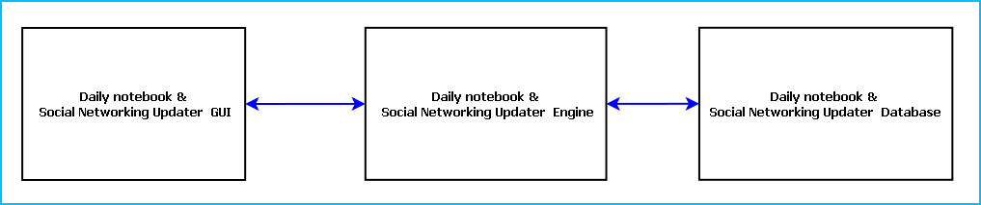
Figure: Main components of Daily notebook & Social Networking Updater

Daily notebook & Social Networking Updater GUI
Daily notebook & Social Networking Updater will allow user to add daily notes, update them in the social networking sites and view RSS feed updates of their favorite sites. The GUI module is divided into 14 components. Such as:
- View Manager  - Daily Note Interface  - Task / To Do Interface  - Common Controls  - Search Interface  - RSS FEED Interface  - Archive Interface | - Facebook Interface  - Twitter Interface  - Blogger Interface  - Linkedin Interface  - Google buzz Interface  - Orkut status Interface  - Engine Interactor

View Manger:
View Manager controls the interaction between different views. It handles the GUI flow and the look and feel of the application. It manages the components of the GUI. View Manger keeps track of user preferences and displays the data according to it.
View Manager enables user to choose the view to be displayed and sort the data entries according to name, time etc.
In this software variable number of views can be displayed. All the views can be arranged as a tabbed/ Split window.

Common Controls:
Common controls include several controls of the application. Such as: Menu Bar, Toolbar, status bar, Context Menu and progress bar.

Engine Interaction:
This module handles the interaction between GUI and Engine. This module defines all callback for the Engine events.
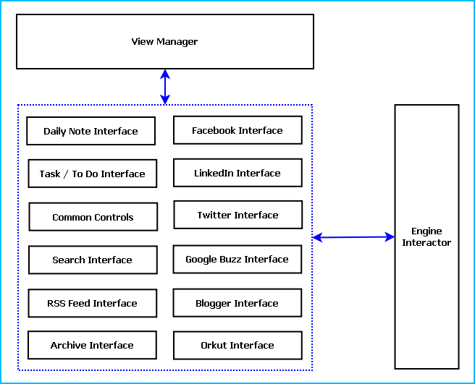
Figure: Different GUI Components

Search Interface
This interface enables user to search any of the updates, notes and RSS feeds from current view port as well as from the archived database. It will have provision for entering search item and selecting the type of search as well as advanced search options.

Facebook Interface
This interface will allow connecting to the facebook site, access login information. It will provide RSS feeds from facebook site. It will display only the text and link of the multimedia contents for time being.

Twitter Interface
This interface will allow connecting to Twitter site and gain the authentication. It will display user’s twitter stream and the other feeds he follows.

Daily Note Interface
This interface will allow user to insert notes and he can choose the services or sites to be updated also. The UI will have a text area where he can enter text and tick the check boxes corresponding to social networking sites to be updated.
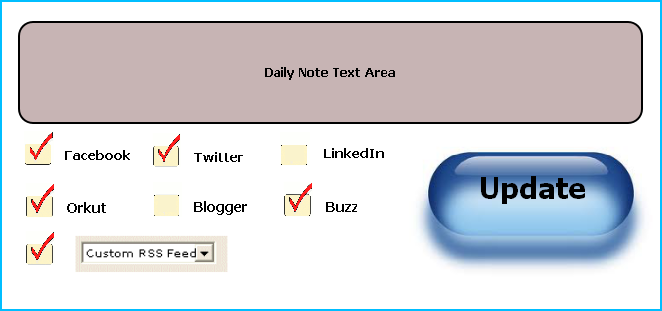
Figure: Daily Note Entry GUI Layout

Blogger Interface
This interface will allow authentication of Blogger access and display Blogger feeds which the user like to follow.

Linkedin Interface
This interface will display the updates from LinkedIn friends, InMails and connection requests. It will allow connecting the LinkedIn site.

Google buzz Interface
This interface will update the Google Buzz notifications from the user’s existing friends. It will also have an interface to login using Google Open ID for authentication.

Orkut status Interface
This interface will display Orkut updates, friend’s scraps, messages and other notifications. It will allow user to login using Orkut User name and password.

RSS FEED Interface
This will allow user to subscribe with any RSS feed and get regular updates from that feed.

Task / To Do Interface
This interface will allow user to add task list and modify it if required. User can add alarm or notification along with a task.
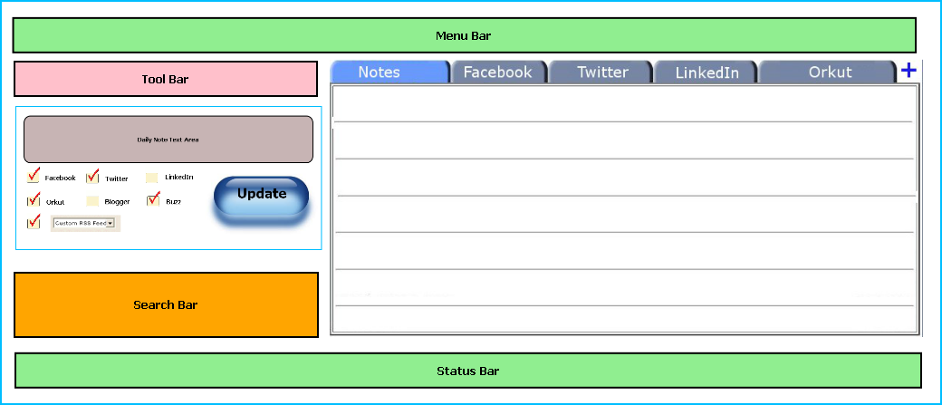
Figure: GUI layout & Placements

Archive Interface
It will allow user to archive old data. User can select data according time, size or service and archive them for saving disk space.

Daily notebook & Social Networking Updater Engine
Daily Notebook & Social Networking Updater Engine controls the logic and mechanism of the application. It processes the GUI requests and interacts with Database and the web feeds. This module is divided into 8 segments. Such as:
- Daily Note Handler
- Task / To Do Handler
- RSS Feed Watcher
- GUI Interactor
- Database Manager:
- Search Engine:
- Web Service Handler:
- Data Update Manager
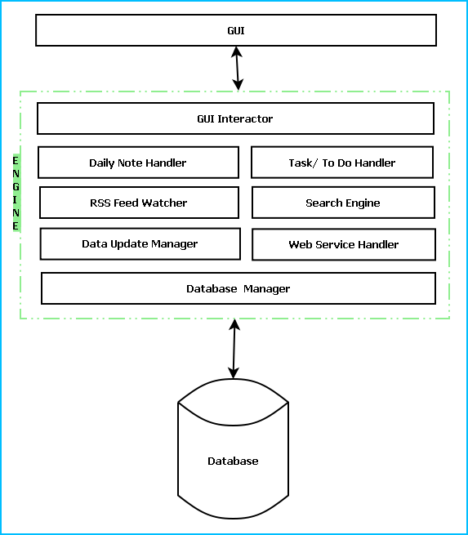
Figure: Engine layers along with interaction with GUI & DB.

Task / To Do Handler:
This module will process the user entered data for Task/ To Do list. It schedules the alarm notification depending on the user preferences.

Daily Note Handler:
Daily Note Handler processes the notes entered by the user. It saves the note in database by passing it to Database Manager. It also saves necessary information like user, time, account and other preferences. Depending on the user input passes the daily note content to the appropriate web service handlers.

RSS Feed Watcher:
This module will poll for RSS feed updates in specific websites. It will download the Feed change and pass it on to the appropriate handler.

GUI Interactor:
This module interacts with GUI module and serves GUI action request. It exposes events to GUI to notify some special actions along with required data.

Database Manager:
This module manages the database. It handles information saving in database, retrieval of information from database.

Search Engine:
Search engine enables rapid and efficient searching of data. Search Engine prepares search indexes depending most accessed data. It improves the efficiency and performance of the software.

Web Service Handler:
Web controller handles the interaction with web services like Facebook, Twitter, Orkut. Web service handler will associate a separate instance for each web service. It keeps track of authentication session, sends data and receives updates.

Data Update Manager:
It controls the incoming data from web service handlers and passes the updates to appropriate web service handler. It is a bridge between Daily Note handler and web service handlers. It validates the data depending on predefined inputs. If validation is failed it generates warning messages.

Daily notebook & Social Networking Updater Database
Daily notebook & Social Networking Updater Database will be an optimized database which will save updates from every web service as well as the notes entered by the user. We will use RDBMS concept.

Hardware & Software required for the application to run

Hardware Requirements
- Computer that has a 1.6GHz or faster processor
- 1 GB (32 Bit) or 2 GB (64 Bit) RAM
- 10 MB of available hard disk space
- DVD-ROM Drive / USB Port

Software Requirements
- Windows XP (x86) with Service Pack 3 / Windows Vista (x86) with Service Pack 2 / Windows 7 (x86)
- Microsoft .NET 4.0

Project Structure:

Project Estimation:
Task Group | Task | Duration ( Man-Days)
GUI | GUI design | 75 days
GUI | GUI functionality implementation | 75 days
GUI | View Manager | 75 days
GUI | Daily Note Interface | 75 days
GUI | Task / To Do Interface | 75 days
GUI | Search Interface | 75 days
GUI | RSS FEED Interface | 75 days
GUI | Archive Interface | 75 days
GUI | Facebook Interface | 75 days
GUI | Twitter Interface | 75 days
GUI | Blogger Interface | 75 days
GUI | Linkedin Interface | 75 days
GUI | Google buzz Interface | 75 days
GUI | Orkut Interface | 75 days
GUI | Common Controls | 75 days
GUI | Engine Interactor | 75 days
Engine | Engine Design | 45 days
Engine | Daily Note Handler | 45 days
Engine | Task / To Do Handler | 45 days
Engine | RSS Feed Watcher | 45 days
Engine | GUI Interactor | 45 days
Engine | Database Manager: | 45 days
Engine | Search Engine: | 45 days
Engine | Web Service Handler: | 45 days
Engine | Data Update Manager | 45 days
Database | Database Design | 15 days
Database | Database Implementation | 15 days
Integration | Application Integration | 15 days
Integration | Creating Installer | 15 days
Testing | Unit Testing | 15 days
Testing | Integration Testing | 15 days
Testing | Regression Testing | 15 days
Testing | System Testing | 15 days
Documentation | Synopsis | 15 days
Documentation | Design Document | 15 days
Documentation | Help Document | 15 days

E-R Diagram:
We will design a RDBMS for Daily notebook & Social Networking Updater. The entities and their attributes are listed below. Attributes in Bold letter is the unique key.
Entities | Attributes
Note | Note Id, Content, Time, Size, Web Service id, user
RSS Feed | RSS Feed Id , Web Service Id, Content, time, size
Daily notebook & Social Networking Updater | Sw Id, Web Services Supported, Users, Size
User | User Id, Name, Social Network Data, Preferences.
Web Service | Web Service Id, Authentication Data, Feed Data, Preferences.

Relationship between Entities:

- Daily notebook & Social Networking Updater has User → 1 : N
- Users post Notes → 1 : N
- Web Service generates Feeds → M : N

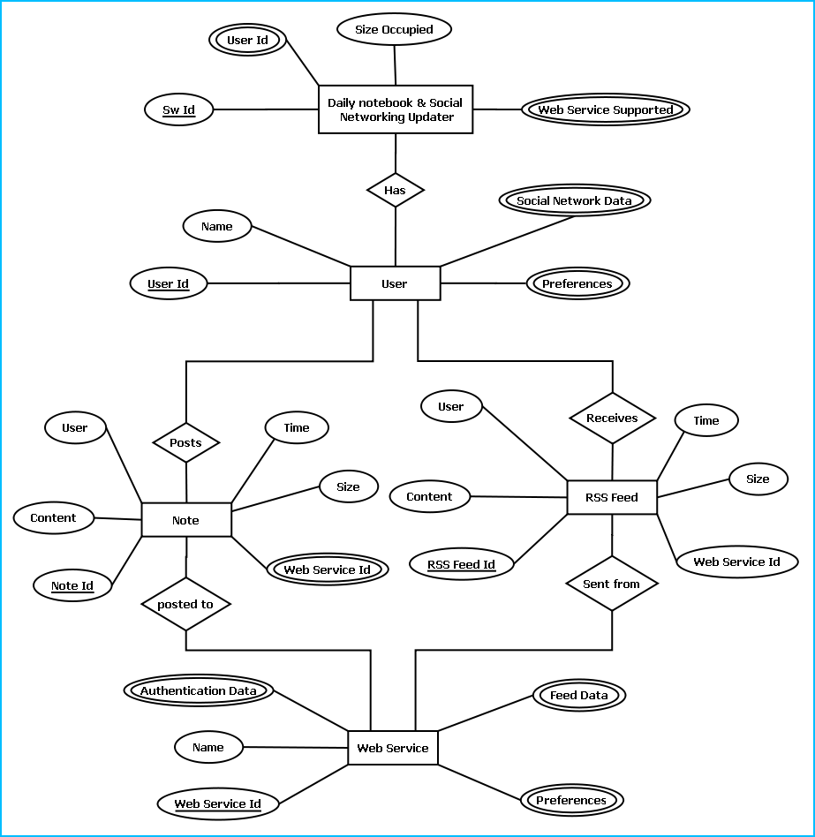
E-R Diagram of Daily notebook & Social Networking Updater

Tools/Platforms used (Hardware/Software):

Hardware:
- Laptop with 2GHZ processor
- 2 GB RAM
- 320 GB hard disk (NTFS File System)
- 8 GB USB Pen Drive (FAT File System)

Software:
- Windows XP (x86) with Service Pack 3 / Windows Vista (x86) with Service Pack 2 / Windows 7 (x86)
- Microsoft .NET 4.0
- Windows Presentation Framework(WPF)
- Windows Communication Framework(WCF)
- Visual Studio 2010 Express Edition (IDE)
- MySQL database
- Dia for Diagram Drawing & Modeling.
- Google App Framework
- Facebook Php Sdk & FBML
- Twitter Sdk
- LinkedIn Sdk
- RSS Feed Burner Sdk

Any Client/Industry:

E-Komfort Zone
Bamangachi Station Road,
P.O: Bamangachi, P.S: Barasat,
Dist: North 24 Pgs
West Bengal- 743706

Future Scope and Further enhancement of the project:

- Now it will display the text based RSS feeds and link of the multimedia contents. We will display the Multimedia contents like Video, Audio & Image in future.
- To support UNIX / Linux Based Operating systems.
- To Support Mobile Operating systems for Symbian, Meego & Android.

----------------------------- Thank You-------------------------

